Jan Dudek, 286161

**1st Report**

**Introduction:**

The purpose of this project was to create program to generate different microstructures based on given parameters, such as initial nucleons number, shape, size and number of inclusions or transition rules. Implemented program run cellular automata based on those parameters to create specific microstructure.

**Technology stack:**

For creating the project C# language was used, along with Windows Forms framework. The choice of technologies was made given the fact that Windows Forms provides the Graphical User Interface Designer which is very easy to use. This enables one to create a basic GUI quickly and concentrate on the backend side of the application. Windows Forms implements a “free-style” version of MVC design pattern and has all the tools needed for creating presented project, such as built-in functions to import and export bitmaps, mechanisms to display them and easy to use tools to manage and customize lists in view.

**Project description:**

The project was created in five consecutive steps extending its functionality:

1. Nucleation and simple grains growth based on von Neumann transition rule
2. Import and export structure to txt and bmp file
3. Adding inclusions at the beginning and after growth, inclusions do not take part in growth
4. Grain growth with extended Moore transition rules
5. Dual-phase structure generation

**Graphical User Interface:**

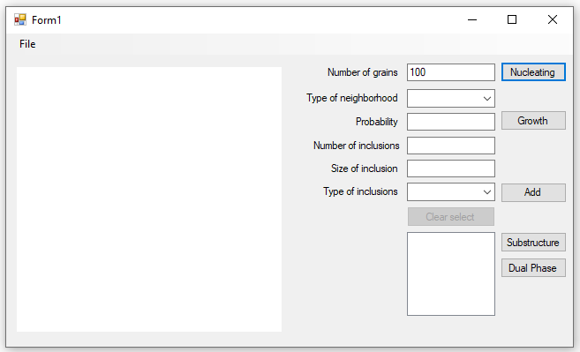

Image 1 Applications main window

Application window, shown on Image 1, contain square picture of microstructure and controls which allows user to control and modify structure. Each of image pixels represent single automata cell. When pixel is white it means that a cell does not belongs to any grain, each grain has its own colour. Black cells belongs to inclusions and do not take part in growth. Cells which were selected to generate dual phase structure are magenta.

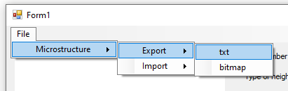Microstructure export to txt and bmp files along with import from txt files is available from applications File menu shown on Image 2.

Image Applications menu

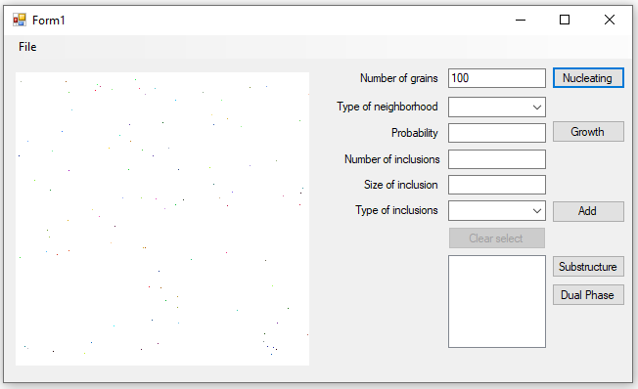To generate microstructure, first user have to provide number of grains and press “Nucleation” button. As a result given number of nucleons (single cell grains) will appear on microstructure (Image 3).

Image New nucleons

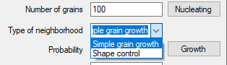Then to generate microstructure used have to choose type of neighbourhood (Image 4).

Image Selecting type of neighborhood

And, in case of shape control, determine probability for extended Moore transition rule:

Image 5 Applying probability for extended Moore transition rule

Pressing “Growth” button will initiate microstructure generation process, and button label will change to “Stop”. Pressing that button will stop microstructure growth. A result is shown on Image 6. To insert inclusions into microstructure user have to provide number, size and type of inclusions (Image 7). Inserting nucleons on empty microstructure will result in random placement of inclusions, as shown on Image 8.

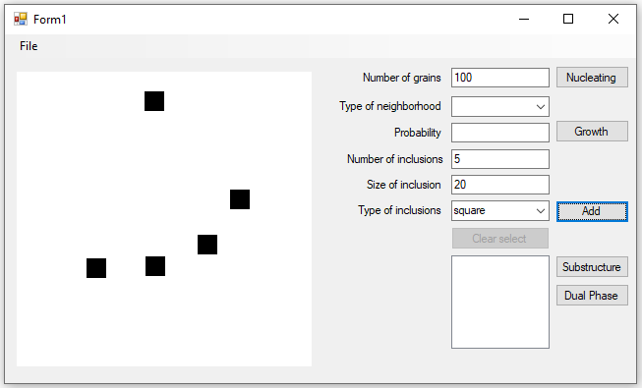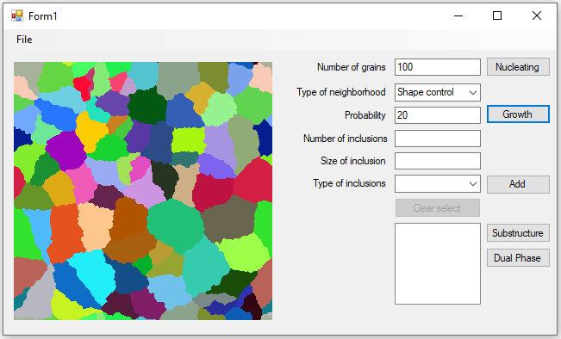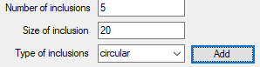Inserting inclusions on already generated microstructure will produce new inclusions only on grains edges, like presented on Image 9.

Image 8 Incusions on empty microstructure

Image 6 Generated microstructure

Image 7 Inseting parameters for inclusions generation

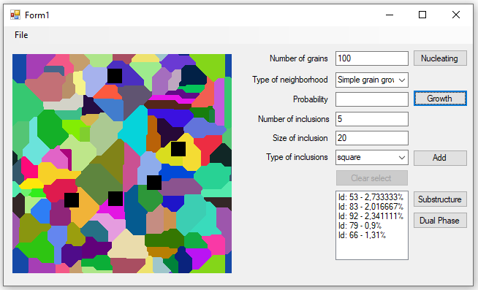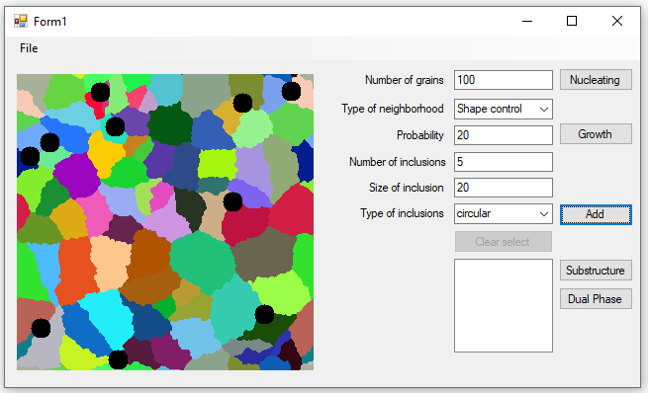After microstructure generation user can select grains which will be used in dual-phase microstructure by clicking them. Selected grains will appear on list in bottom right corner of window (Image 10).

Image 10 List of selected grains

Image 9 Inclusions on pre-generated microstructure

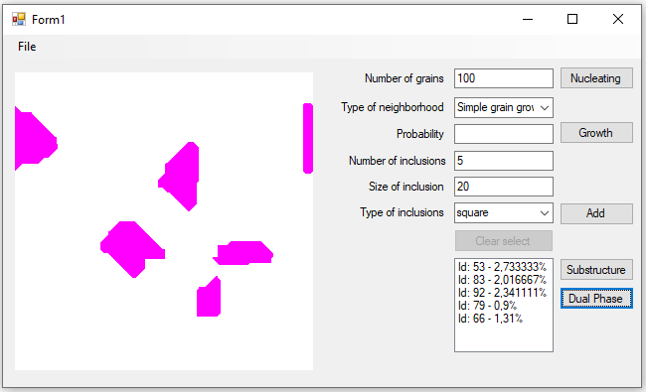After pressing “Dual Phase” button all grains that were not selected are removed from microstructure and selected grains change colour to magenta (shown on Image 11). From now on those grains will not take part in grains growth. New nucleons can be generated and microstructure can be regenerated like on Image 12.

Image 11 Grains selected for dual-phase generation

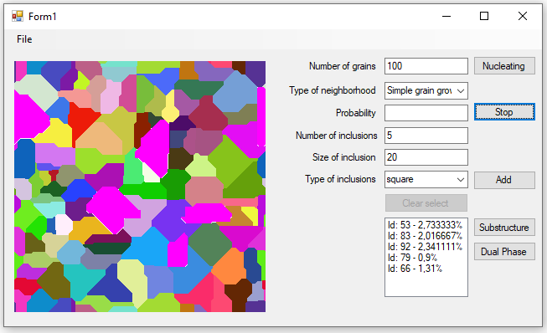Microstructure is stored in 2 dimensional list of cells. Each cell store information about grain which it belongs to. Each grain store information about colour which represents it. Empty cells has grain identifier set to -1, cells that belongs to inclusions has grain id -2 and cells that were selected to dual-phase generation has grain identifier set to -3.

Image Dual-phase microstructure

**Comparison with real microstructure:**

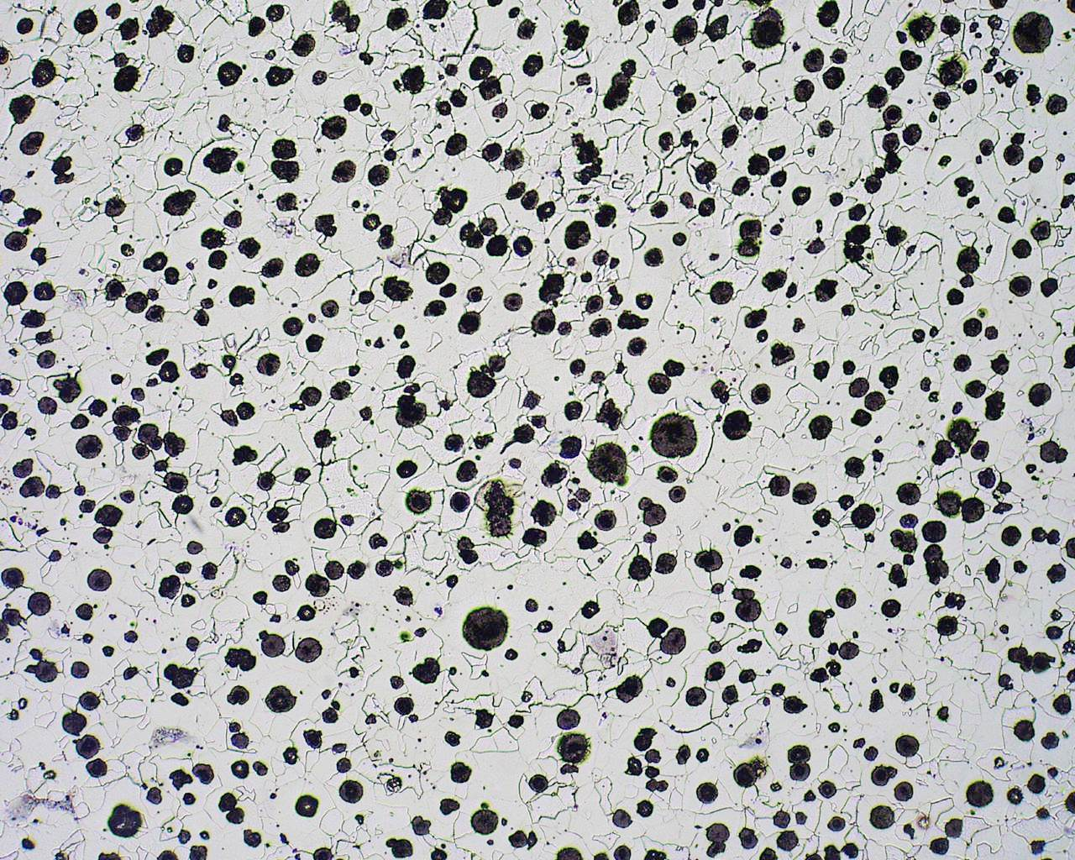Spheroidal cast iron:

<http://metlabsaust.com.au/wp-content/uploads/2016/03/Spheroidal-graphite-cast-iron.jpg>

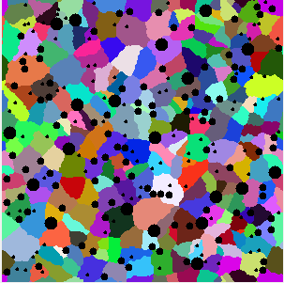Conclusion:

It is possible to generate similar microstructure with implemented program, but it requires repeatedly adding inclusions with different dimensions and also trial and error method, because not every time the structure generated has satisfactory resemblance. Also the real inclusions have much more irregular shapes, some of them are more elliptical than circular and even that applies only to the most regular nodules. There are a lot of cases when these nodules have shapes more similar to the irregular grains than any other shape. This significantly limits the applicability of this program.

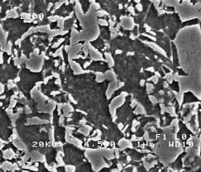Dual-phase steel:

<https://kundoc.com/pdf-dual-phase-steels-microstructure-and-properties-consideration-based-on-artificia.html>

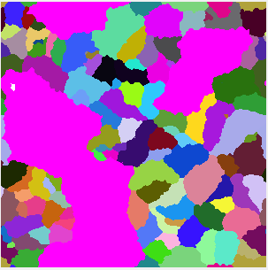

Conclusion:

The artificially generated structure looks somewhat similar to the original one. The problem is that if one wanted to recreate the original structure precisely, he would have to spend a lot of time on that. It is because there are both very small and very small elements in the structure. To be able to select the small ones one would have to generate the microstructure with a lot of small grains but then it would take a significant amount of time to compose the larger elements of the structure out of these small grains or regenerate the structure with larger grains and select some of them. However, this approach is more like drawing the microstructure manually than automatically generating it.

General Conclusion:

Although created program has limited application, it can be used to create microstructures resembling the real ones. It requires a lot of manipulations with parameters and also a lot of patience because of the trial/error approach. Some elements in the project could certainly be improved. Inclusions in their current form have very limited appliance because of their regular shapes and orientation. They would look much more realistic, if there were a possibility to add some imperfections to them, or at least elliptic shape. Von Neumann transition rule used in the most basic grain growth algorithm did not give good results in comparison with real microstructures, but Moore transition rule with adequate probability can create grains with quite realistic shapes although the grains’ boundaries are jagged and inadequate. Larger number of transition rules would improve this project possibilities too. It would make possible to create the grains with more smooth, yet natural-looking edges.